Troop Dashboard

Your Digital Cookie Dashboard has information that helps you support your girls and their parents in their digital cookie sales. The dashboard has been updated this year to accommodate the troop link setup and give you more visibility and clearer information on what the girls in your troop are doing in Digtial Cookie.

All appointed Troop Leaders and Cookie Volunteers for the troop should have access to this Dashboard when they login to Digital Cookie.

This year there are two separate tabs on your Troop Leader section.


Dashboard
My Troop

Dashboard

The dashboard has three sections.
- Troop Link info
- Troop Online Sales and Marketing
- Reports

Troop Cookie Site Info

For more details about this section and setting up your Troop Cookie Link, please see the “Troop Direct Ship Link” tip sheet.

You will also see on the right hand side of this section if any girls/parents have turned off a variety or in-person delivery in their site. For details on that function for parents, view the “Parent Inventory Tab” tip sheet.

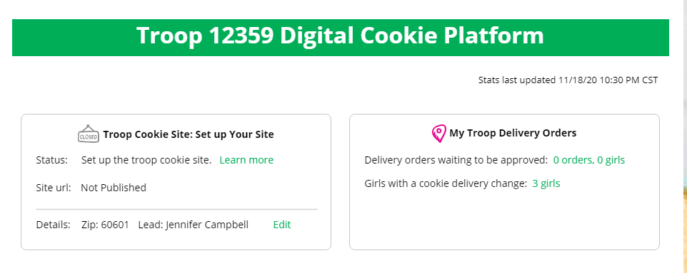

Troop Online Sales and Marketing
This section will show you the sales for the girls in your troop at a glance. It’s a great way to make sure they are actively participating in reaching their customers.

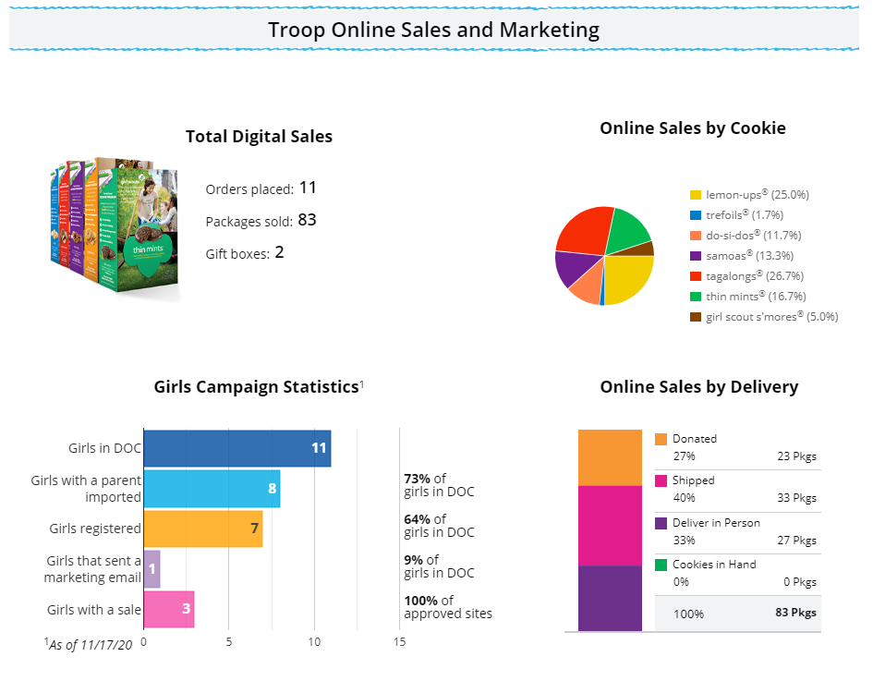

Reports

You have three reports to view that can help you manage your girl’s Digital Cookie activity.
- “All Order Data” will show you details on every order for every girl.
- “Initial Order” (If applicable) will show you the initial paper order card entry by the parents to allow you to easily enter their orders into eBudde.
- “Cookie Badges” will let you know if girls are completing any of the Cookie Business badges and/or the Family Entrepreneur Pins. Encourage them to complet these with their families to increase their cookie program learnings!
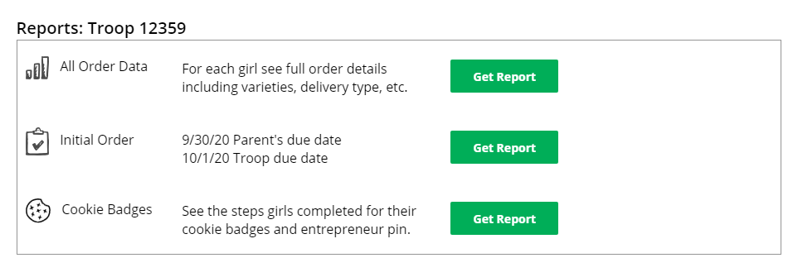


My Troop
Use this tab to see many sale details for each girl in the troop.

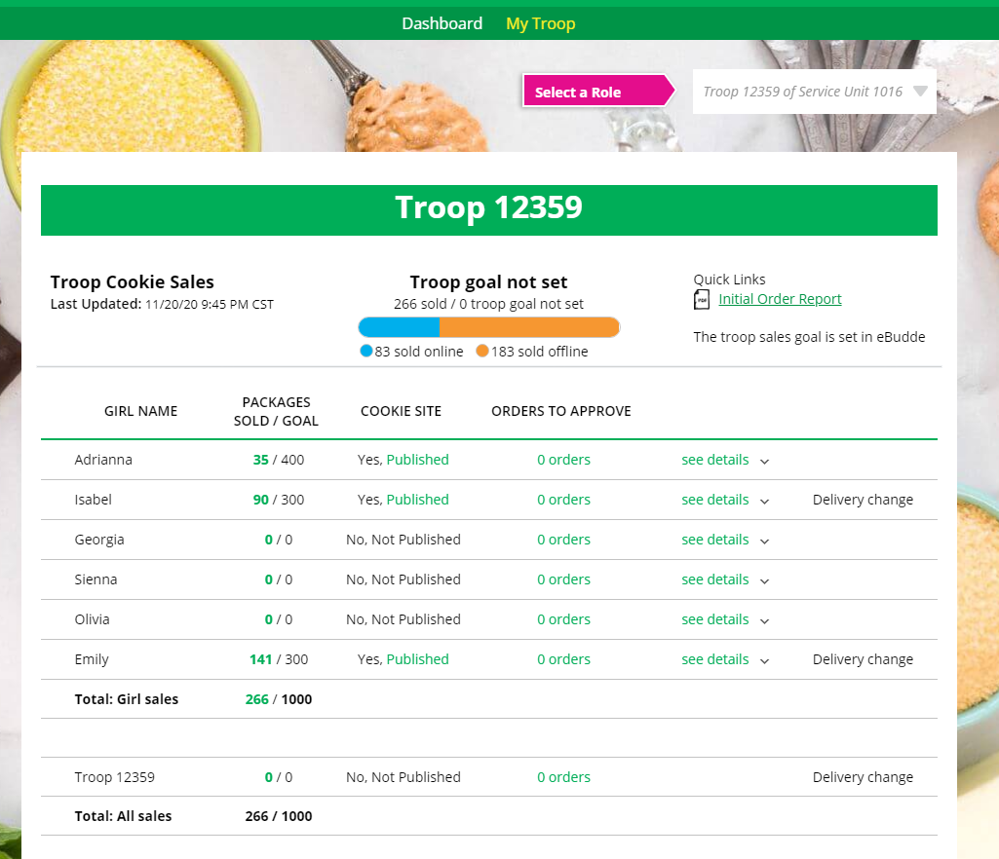
5
4
1
2
3

- Troop Goal
This pulls the troop goal set in eBudde and measures the troop’s progress towards that goal. If the goal has not been set yet, it shows total troop’s sales to date.

- Cookie Site
If the girl’s site is published, click on the link to be taken to her customer facing site. If it shows as Not Published, offer to help the girl and her family to help her get started and seeing sales roll in.

- Orders to Approve
If your council has In-Person Delivery available you can see details on what orders the parent needs to approve and what cookies they may need to fulfill orders.

- See Details/Delivery Change
Clicking “See Details” will bring up details on the girl, her orders, her email marketing to customers and if her parent has turned off delivery or any varieties (if available in your council).
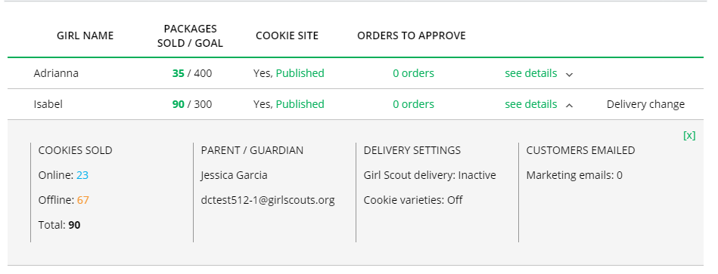

- If your troop link has been published you will see what the goal is for the Troop ##### “girl”, you can click the link to go to the troop site and you can see any sales that have come in for the troop link.

.
Other useful trainings: Troop Leader: Order Received Shipping
Troop Leader: Order Received: In-Person Delivery

